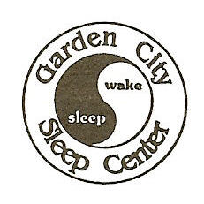
Garden City Sleep Center Pulmonary, Allergy & Sleep Disorders
1101 Stewart Ave, Suite 101, Garden City, NY 11530 Tele: 516- 741-0055, Fax: 741-6936 G. S. Gill, MD, FCCP, FAASM Fellow, American College of Chest Physicians & American Academy of Sleep Medicine
Susan M. Gill, MS, FNP-BC, CPNP, PMHNP Family, Pediatric & Psych Mental Health Nurse Practitioner

There are 2 different types of Asthma based on “triggers”

- Allergic Asthma
- People with this type of asthma often have a personal and/or family history
of allergies.
- Seasonal Asthma is a form of allergic asthma and can be triggered by trees
or grass that release pollen into the air. For example, some people find their
asthma is worse in the spring. When there are more plants in bloom. Others
find their asthma is worse in late summer or early fall when ragweed is more
likely to cause problems.
-Among the most common allergens are:
- Pollen
- Dust Mites – these are bugs so small that you can’t see them.
You may help reduce your symptoms by washing
sheets, pillow cases, and comforters in hot water
which will get rid of dust mites.
- Mold spores
- Animal Dander- Pets have dander which are tiny bits of skin and
saliva that can trigger asthma symptoms. So if
you have a pet with fur or feathers keep it out of
your bedroom.
- Non Allergic Asthma
- Your asthma attacks may have nothing to do with allergies, but like any person
with asthma your attacks may be triggered or made worse by one or more non
allergic asthma triggers. These can include things in the air you breathe,
infections like the common cold may also cause symptoms. You can prevent
infections in the Upper Airway by doing the following:

- Wash your hands frequently .
- Have a yearly flu vaccination.
- Avoid contact with people who have the flu.

-Common Triggers

- Irritants, dust, wood-burning stove, aerosol sprays and other types of
strong odors.

- Another growing problem is air pollution. More people who live in cities, especially children, are getting asthma. The role of air pollution in asthma
is being studied.

- Heartburn- if you have heartburn ask your doctor if treating it could help
reduce your asthma symptoms.

- Cigarette smoke is a major trigger of asthma symptoms. Even second
hand smoke can raise the risk of asthma in children.
-About half of the adults over age 40 who get asthma have
smoked cigarettes. They’ve also had long-term problems.

- There is no way to know who will get asthma and triggers vary from person
to person

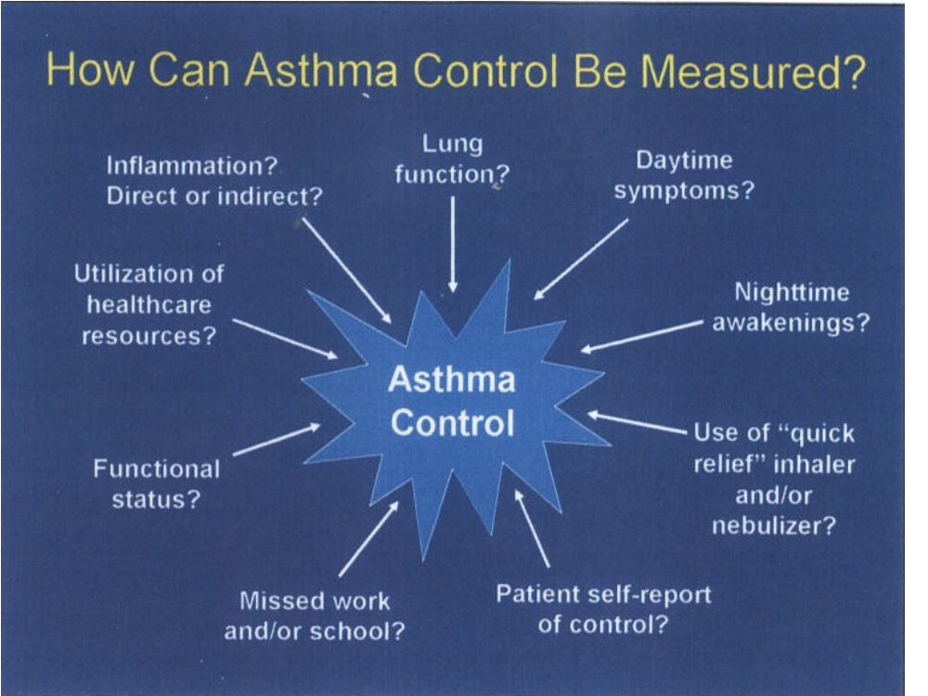

Early signs of an Asthma Attack
These signs include:
  - Lower peak flow readings than your personal best readings.
  - Coughing a lot, especially at night.
  - Losing your breath easily or being short of breath.
  - Feeling very tired or weak during excercise.
  - Wheezing or coughing after exercise.
  - Cold or allergy symptoms (sneezing, runny or stuffy nose, cough,
sore throat, headache).
  - Trouble sleeping due to breathing problems.

Peak Flow Readings

Green means GO! : Greater than or equal to 80% of your personal best peak flow.
Use your current medications to prevent asthma symptoms prescribed.

Yellow means CAUTION! : 50% to less than 80% of your personal best peak flow.
Take other medicines as your doctor tells you to.

Red means STOP! : Below 50% of your personal best peak flow. Get help from your
Doctor.

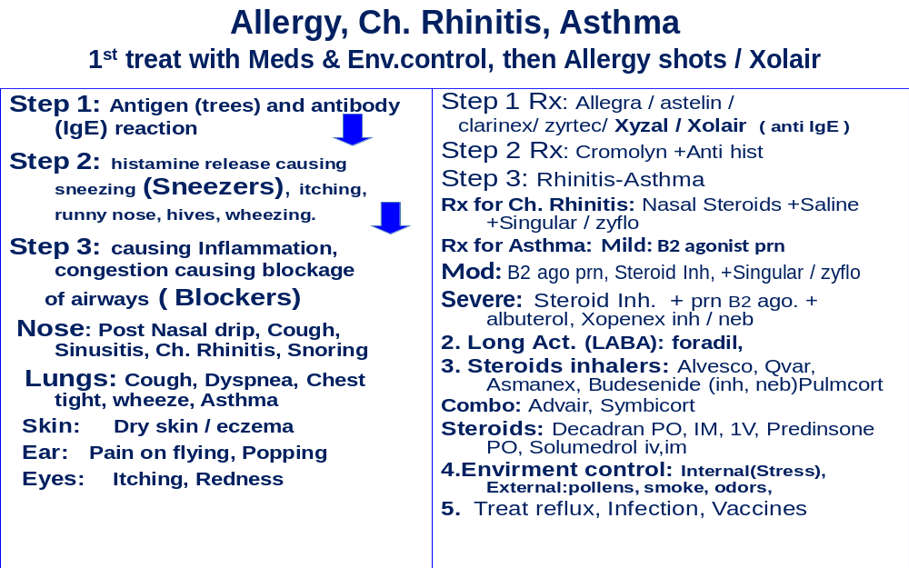

Medication: Determined By Severity Level

- Mild Intermittent
- Use reliever only as needed.

- Mild Persistent
- Use controller and reliever.

- Moderate Persistent

- Use controller plus long-acting bronchodilator and reliever.

- Severe Persistent
- Use Controller plus long-acting bronchodilator and reliever.

Rhino Sinusitis Control Decreases Severity of Asthma
**Dr. Ramon Figueroa-Lebron-Asthma Management Center, San Juan, PR

PURPOSE: Chronic non allergic Rhinosinusitis accounts for 1/3 of visits to physicians offices. In many of our asthmatics, cough is the presenting symptom. This study is to evaluate benefits of daily nasal steroids and HT1 blockers in decreasing severity of bronchial inflammation, improvement of disease control and quality of life.

METHODS: Study is a retrospective observational based on Blue Shield Puerto Rico expenditures of all services and medications paid in 2004 for the population of this study and the control patients. The subjects were 358 patients referred to center because of refractions to management. Control population consisted of 12,070 asthmatics treated by the neurologists’ in the community. Inclusion criteria were: an age of 12-17 years, presence of Rhinosinusitis, cough as prominent symptoms, severe airway obstruction shown by Spirometry and low Peak Flow (PEF) readings, prior visits to emergency department and or hospital admissions in 2003.

CONCLUSION: The study showed an impressive improvement in severity of airway obstruction and symptoms complex with 88% less hospital admissions and a dramatic decrease in the use and cost of controller medications. Use of daily nasal steroids is of great benefit in the majority of patients.
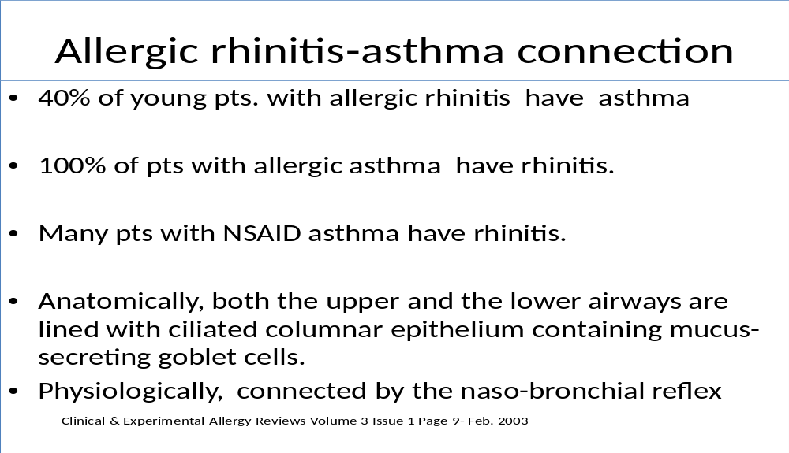

Causes of Chronic Cough
Causes | Percentage
PNDS | 52
ASTHMA | 25
GERD | 24
CHRONIC BRONCHITIS | 8
BRONCHICTASIS | 4
MISCELLANEOUS | 5
PNDS-ASTHMA-GERD | 90

Up to 75% of the time when GERD is a cause of chronic cough, there may not be GI symptoms.

A cough- reflux self- perpetuating cycle is likely to exist: whereby cough from any other cause may precipitate further reflux.

Therefore, in managing a chronic cough, you will have to treat other simultaneously contributing conditions.

ENVIRONMENTAL CONTROL
( Cleaning Solutions )

The Environmental Association for Great Lakes Association has laid our very simple tips, amongst many other ‘green-friendly’ organizations. Some of the tips are very easy to follow:-
1 . Use mild, homemade cleaner, Following is a list of cleaners you can make
from easily available ingredients.
- All purpose cleaner – Mix Borax with clean water
- Window cleaner – use vinegar or lemon juice mixed with water
- Disinfectant – use natural tea tree oil mixed with the water and/or
borax
- Mold Killer – use vinegar
- Stain remover – use baking soda
- Tub and tile cleaner – mix baking soda with natural soap and water
- Clogged drain – pour a cup of baking soda, followed by 3 cups of
hot water, and if necessary follow with a cup of vinegar
- Brass cleaner – use yogurt or tamarind
- Oven cleaner – sprinkle a thin layer of baking soda, and dampen with
water. Leave it overnight, and dampen with water again if necessary.
Clean it out in the morning.
- Furniture cleaner – mix olive oil and vinegar.

2. Clean with non- aerosol spray bottles – since the aerosol sprays throw
miniscule droplets of chemicals in the air.
3. Avoid anti – bacterial soap – since these soaps kill good germs and bad germs, and contribute to the growing problem of bacteria mutating to strains
that are antibiotic resistant!
4. Avoid ‘dry- cleaning’ totally – and if absolutely necessary, then ensure that
the dry cleaned clothes are hung in an open space for a few days to air out
the dangerous cancer-causing chemicals and perchloroethylene used to
clean them.
- Avoid using chlorine- based products, especially if your family members have asthma or chronic lung or heart problems.

6. Take of your shoes at the door – which is already practiced in most Asian homes.
- Store all the natural and non- green cleaners out-of-reach of children, and use
Labeled containers only
- Do not use the non-green cleaners around children
- Ventilate
- Wear protective clothing.
- Never mix cleaners.

ALLERGY DIET

DO NOT EAT OR DRINK ANY OF THE FOLLOWING FOODS.

- Cheeses (mainly aged or hard ones)
- Mushrooms
- Sausages
- All aged meats
- Vinegar
- Red Wine
- Beer
- Dried Fruits
- Sauces
- Spices
- Pizza
- Chocolate
- Cocoa
- Nuts
- Peanuts
- Peanut Butter
- Fish
- Seafood
- Peas
- Berries

-Dr. Soleymani

Asthma Resources at WebMD:
http://AsthmaResources.webmd.com

Allergy & Asthma Network Mothers of Asthmatics
http://www.aanma.org

American Academy of Allergy, Asthma & Immunology (AAAAI)
http://www.aaaai.org

Asthma & Allergy Foundation of America (AAFA)
http://aafa.org

Asthma Control
www.asthmacontrol.com

National Jewish Medical and Research Center
www.nationaljewish.org

The American Lung Association
http://www.lungusa.org



